Roadmap for Integrating Drone (UAS) Programs into Community College Curricula
Prepared for Community Colleges and Workforce Development Institutions

Purpose
This roadmap provides community colleges with a structured, scalable framework for integrating uncrewed aircraft systems (UAS / drone technology) into existing academic programs. It supports multiple implementation models—from embedded modules to full certificate pathways—while aligning with workforce demand, regulatory requirements, and institutional capacity.
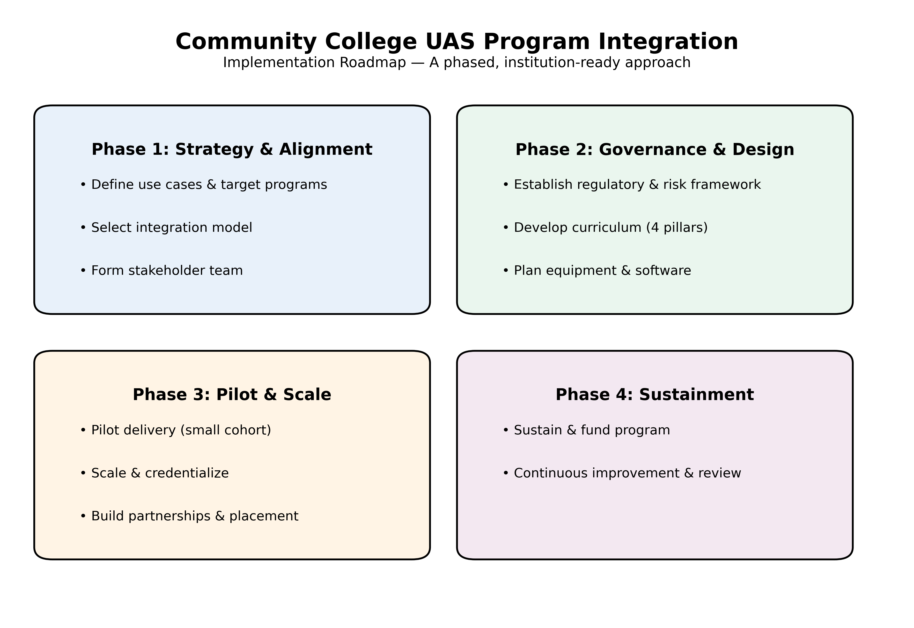

Strategic Rationale
Drone technology is an enabling tool across agriculture, construction, environmental science, public safety, infrastructure, and natural resources. Successful programs integrate UAS instruction into existing curricula rather than isolating it as a stand-alone specialty.

Integration Pathways
• Embedded Modules: Short UAS units added to existing courses.
• Standalone Courses: Credit-bearing drone operations and data courses.
• Stackable Micro-Certificates: Industry-aligned credentials (3–9 credits).
• Full Certificates: Comprehensive programs when regional demand exists.

Core Curriculum Pillars
1. Regulatory & Safety (FAA Part 107, airspace, risk management)
2. Flight Operations (manual and automated missions)
3. Data Collection (mapping, inspection, application)
4. Data Interpretation & Use (industry-specific outcomes)

Implementation Phases
Phase 1 – Pilot: Single course or module (6–12 months)
Phase 2 – Expansion: Stackable credentials and partnerships
Phase 3 – Institutionalization: Certificates, grants, and regional branding

Sustainability & Partnerships
Programs are most sustainable when aligned with industry partners, workforce boards, extension services, and public agencies. Cross-department use of UAS courses improves enrollment efficiency and institutional return on investment.

Contact Information
Dr. Irl “Mike” Davis
UAS Agriculture / sUAS PRO LLC
Website: uasagriculture.com
Email: mdavis@cgcc.edu
Cell: 503-680-6384

